ENGINEERING WORKSHOP LAB
(EL-1006)
LABORATORY MANUAL


Introduction To Version Control: Git & Github
(LAB # 10)
Engr. Hazrat Ali
Student Name: _______Umama Salahuddin_______
Roll No: __25I-6527_____ Section: __C__
Date performed: 24th March, 2026

MARKS AWARDED: ________ / 10

Lab # 10: Introduction To Version Control: Git & Github

Objectives
- Introduction to Version Control Systems
- Introduction to Git and GitHub
- To familiarize with GitHub (Sign-up and Repository Creation)
- To commit changes using Git command line
- Understanding merge conflicts and their resolution

Introduction
Version Control System (VCS): A system that records changes to a file or set of files over time so that you can recall specific versions later. It allows multiple developers to work on the same project simultaneously without overwriting each other's work.
Git: A distributed version control system. Every developer has a full copy of the project history on their local machine.
GitHub: A cloud-based hosting service that lets you manage Git repositories. It provides a web-based graphical interface and collaboration features like bug tracking and task management.
Importance: In professional software and Embedded Systems, version control is vital for tracking firmware updates, managing hardware abstraction layers, and ensuring that a "working" version of code can always be restored if a new update breaks the hardware.

Tools / Requirements
- PC with Windows/Linux/macOS
- Git installed (CLI/Terminal)
- Active GitHub Account
- Text Editor (VS Code, Notepad++, or Vim)

Theory / Basic Concepts
- Repository (Repo): A directory where Git tracks all project files and history.
- Commit: A "snapshot" of your project at a specific point in time.
- Staging Area: An intermediate area where files are prepared before a commit.
- Branch: A parallel version of a repository. It allows you to develop features in isolation.
- Merge: Combining changes from different branches into one.
- Remote Repository: A version of your project hosted on the internet (e.g., GitHub).

Visual Workflow

Git Data Flow Diagram

Branching Logic
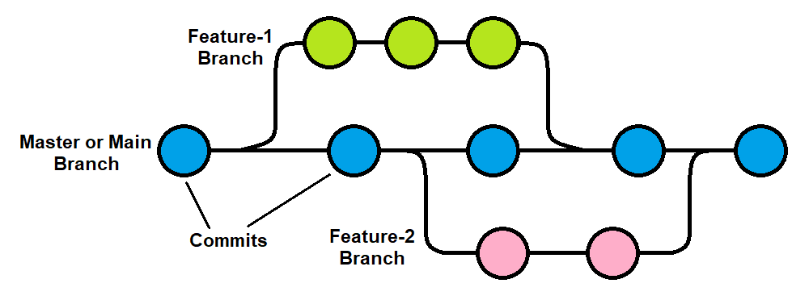

Lab Tasks

Task 1: Git Installation & Setup
Objective: To install and configure the Git environment on the local machine.
# Check if git is installed git --version
# Configure global username and email git config --global user.name "Your Name"
git config --global user.email "yourname@example.com"
# Check configurations git config --list
Cmd Input:
git --version
git config –globa username “abc”
Get config –-global user.email=yourname@example.com
Output: 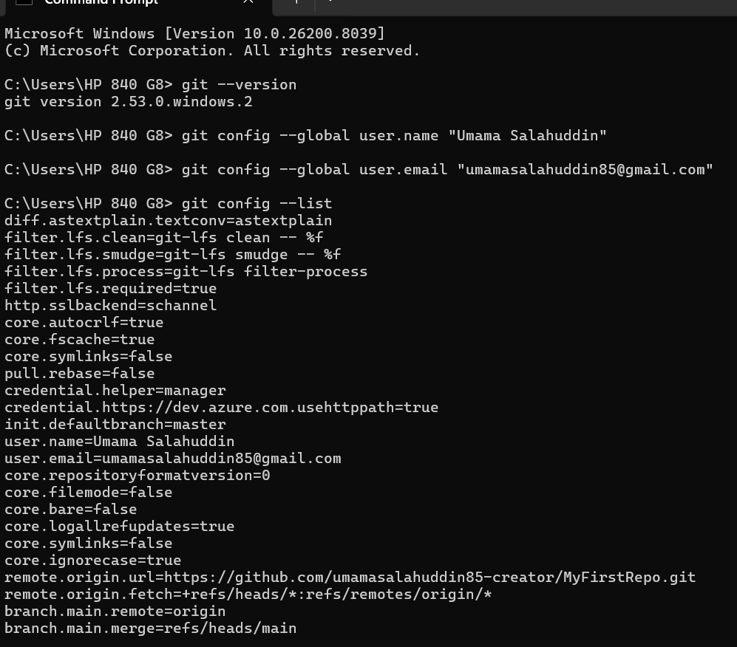

Task 2: GitHub Account & Repository Creation
Objective: To set up a remote hosting environment.
- Go to github.com and Sign Up.
- Once logged in, click the "+" icon and select "New repository".
- Name: MyFirstRepo | Type: Public .
- Initialize with a README.md (Optional).
- Click Create Repository.

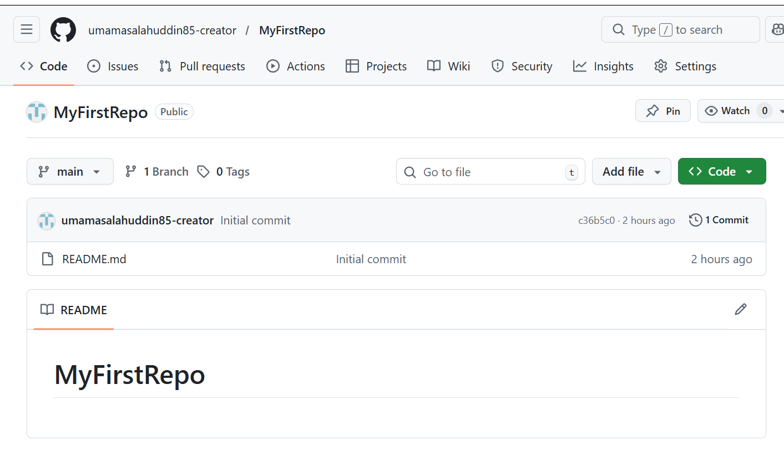

Task 3: Local Repository & First Commit

Objective: To initialize a local project and save changes.
mkdir my_project cd my_project
# Step 1: Initialize Git git init
# Step 2: Create a file
echo "Hello Git World" > index.txt
# Step 3: Add to staging area git add index.txt
# Step 4: Commit to local repository
git commit -m "Initial commit: added index.txt"
Expected Output:
Initialized empty Git repository in ...
[
master (root-commit)] Initial commit: added index.txt
Output: 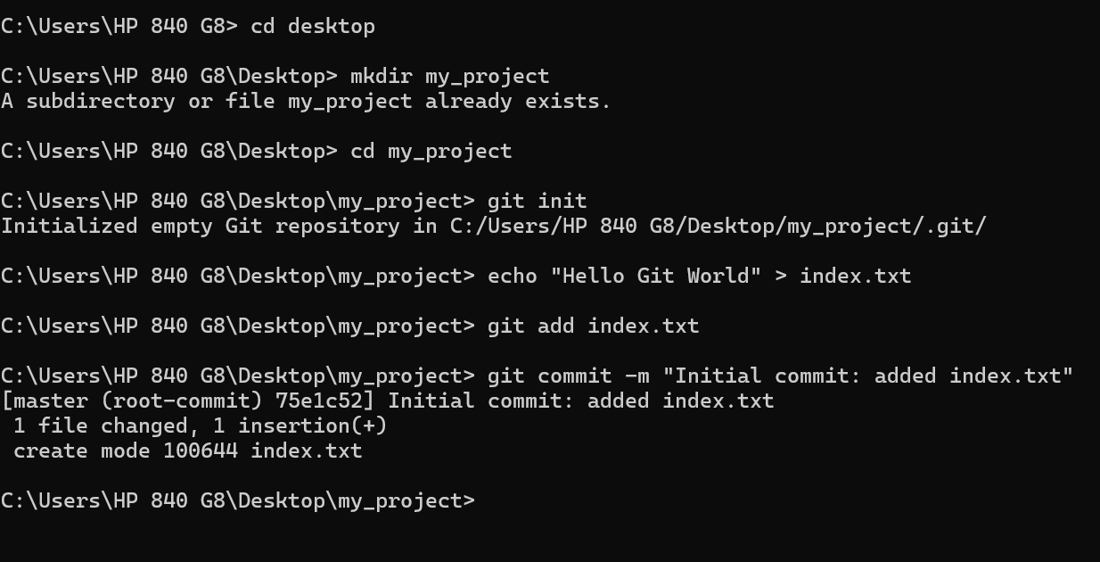

Task 4: Connecting to GitHub

Objective: To link the local repository with the remote GitHub repository.
# Replace with YOUR repository URL
git remote add origin https://github.com/USERNAME/ MyFirstRepo.git
# Rename branch to main (standard) git branch -M main
# Push changes to GitHub git push -u origin main
Expected Output:
Enumerating objects: 3, done.
Writing objects: 100% (3/3), 215 bytes, done.
To https://github.com/USERNAME/MyFirstRepo.git
Output: 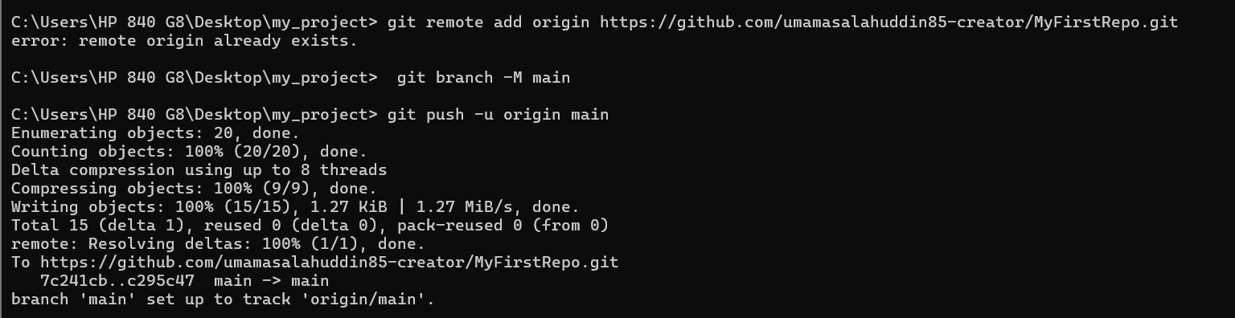

Task 5: Updating and Tracking Changes
Objective: To observe how Git tracks modified files.
# Modify file
echo "Updated content" >> index.txt
# Check status git status
# View differences git diff
# Commit updates git add .
git commit -m "Updated the content of index.txt"

Output: 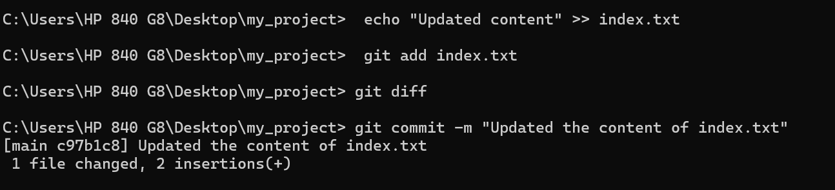

Task 6: Branching and Merging

Objective: isolating feature development using branches.
# Create and switch to new branch git checkout -b feature-cool
# Make changes
echo "Experimental Feature" > feature.txt git add . git commit -m "Added feature.txt"
# Switch back to main git checkout main
# Merge the feature into main git merge feature-cool
Output: 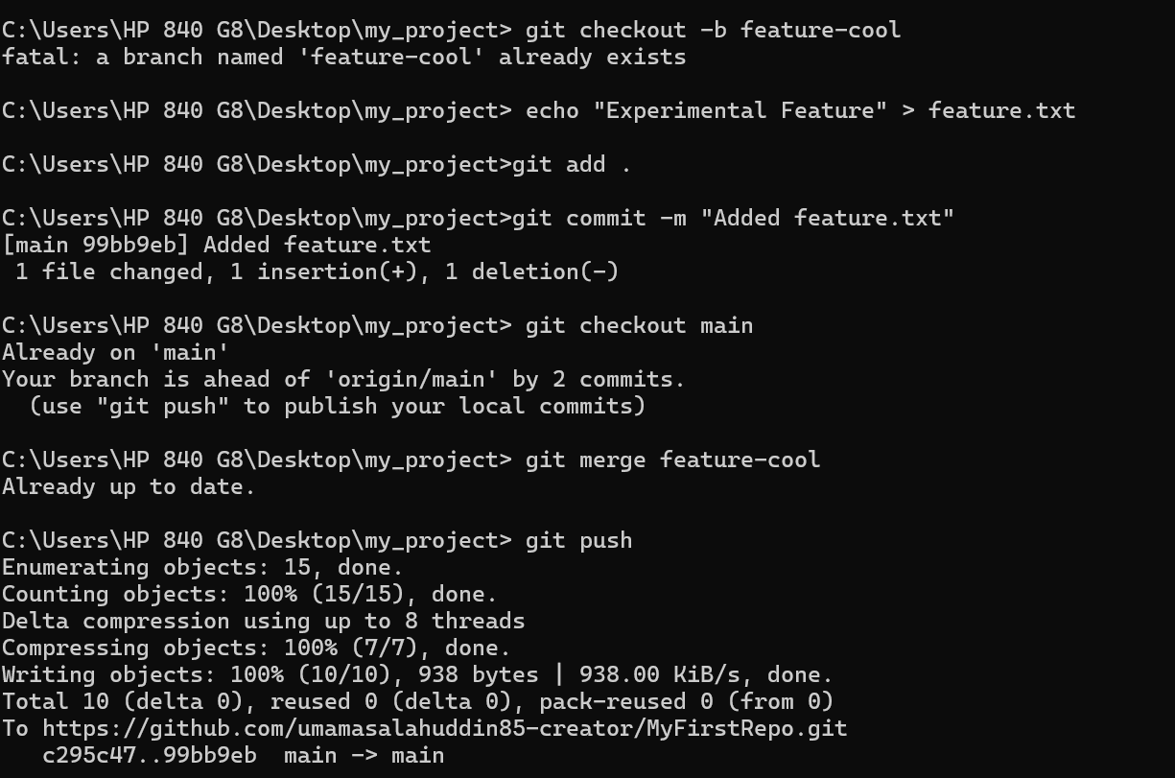

Task 7: Merge Conflicts and Resolution

Objective: To understand and resolve code conflicts when two branches edit the same line.
Scenario: Editing index.txt line 1 in main and feature branch simultaneously.
# In Main Branch
echo "Edit from Main" > index.txt git commit -am "Main change"
# Switch to feature branch git checkout feature-cool
echo "Edit from Feature" > index.txt git commit -am "Feature change"
# Try to merge into main git checkout main git merge feature-cool
Conflict Output:
CONFLICT (content): Merge conflict in index.txt Automatic merge failed; fix conflicts and then commit the result.
Step-by-Step Resolution:
- Open index.txt . You will see markers:
<<<<<<< HEAD
Edit from Main =======
Edit from Feature
>>>>>>> feature-cool
- Delete the markers and choose the desired text (or combine both).
- Save the file.
- Run git add index.txt and git commit -m "Resolved conflict" .

Output: 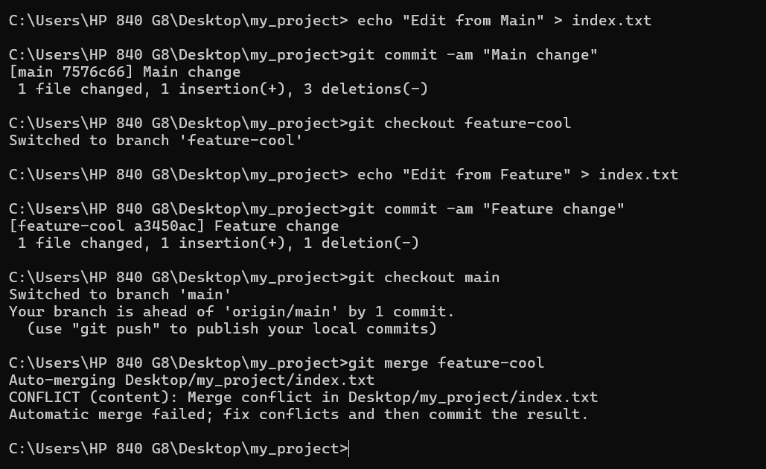
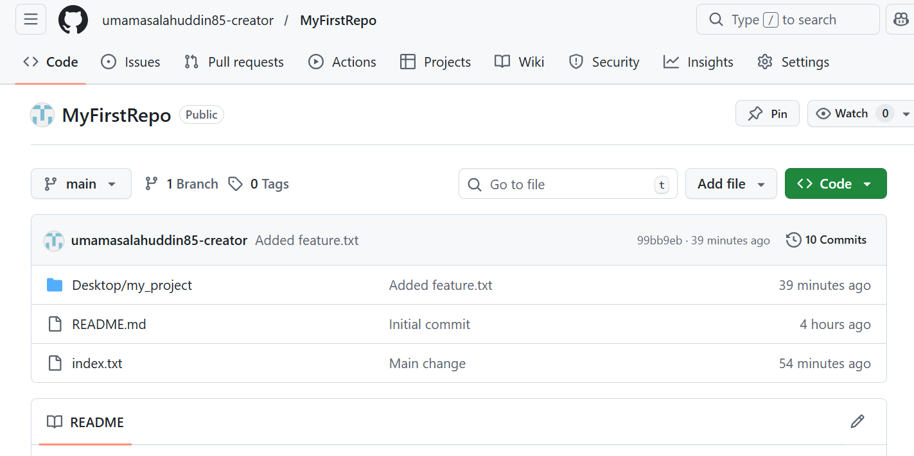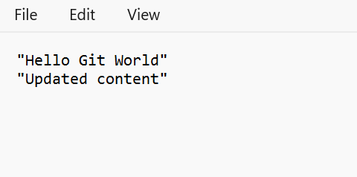

Command Summary Table
Command | Description
git init | Creates a new Git repository locally.
git clone <url> | Copies an existing remote repository.
git add . | Stages all changes in the current directory.
git commit -m "msg" | Saves staged changes to local history.
git push | Uploads local commits to a remote repository.
git pull | Fetches and merges changes from remote to local.
git branch | Lists all branches.
git checkout -b <name> | Creates and switches to a new branch.
git status | Shows state of working directory and staging area.

